**WEATHER App Documentation**

Name - Praful Rana

Enroll no - 9915103059

College - Jaypee Institute of Information Technology

**INTRODUCTION**

This is weather app which gives humidity ,temperature,wind speed when user enter speed with the help of open weather api.

**WEATHER – FUNCTIONAL OVERVIEW**

WEATHER app connects your building control with data from OpenWeatherMap (openweathermap.org) in an intelligent manner. The data allows you to integrate the weather forecast into various algorithms. If, for example, a long dry period is forecast, the watering system can react appropriately and available sun protection systems can be brought into position. If a storm is forecast, the necessary protective measures can be taken automatically. OpenWeatherMap offers codes for a wide range of weather definitions – so-called "Weather condition codes". These codes simplify parameterisation of the system and allow for the clear classification of conditions. Of course current weather information can also easily be shown in the visualisation.

**2 HIGHTLIGHTS**

▪ Current weather for a location per instance

▪ Multi-lingual

▪ Various measurement systems

▪ Automatic or manual "Refresh"

▪ Current temperature

▪ Weather description in the preferred language

▪ Atmospheric pressure

▪ Humidity

▪ Visibility

▪ Wind speed

▪ Cloud cover

1. **Implementation**
2. First we have to register in open weather api to get key.
3. Then we enter city name and create a page by react to show the differenr weather variables

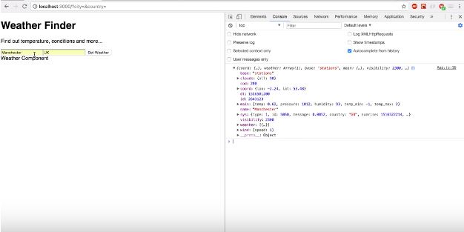

1. Then we have to bring the details in main app page.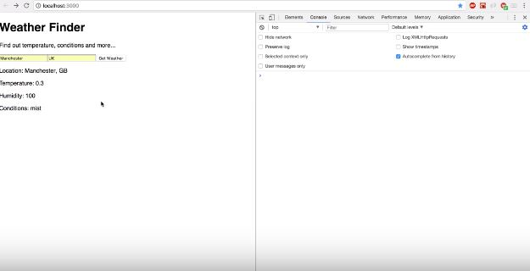

4 then we import bootstrap for futhur customization of web page.

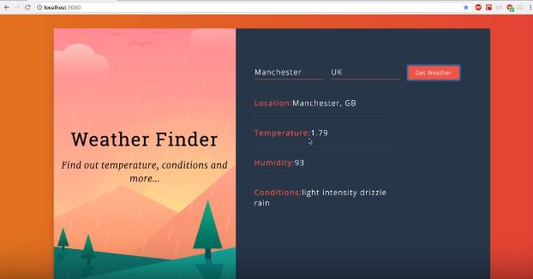

1. **SOFTWARE REQUIREMENT**
2. React JS
3. Bootstrap
4. Java script
5. Html css
6. Public weather api